Complementary Data Description

For data used for the online qualification: all channel data is ideal, with no noise and no Timing Advance (TA). The differences lie in the different scenarios for channel data collection, the number of anchors, and the distribution of anchors. In the finals, all channel data (including anchor points and points to be located) includes noise and TA. Please consider these non-ideal factors in your algorithm design. The coordinates of the anchor points are real coordinates.

#### **Noise**

The noise is white Gaussian noise, with random noise added to different channel data points. The Signal-to-Noise Ratio (SNR) is 0 dB.

#### **TA (Timing Advance)**

The absolute distance of different terminals from the base station are different, leading to differences in the transmission time of the wireless signals. Since the base station uses time-frequency orthogonal multiple access, disorders in the frequency domain of different terminals arriving at the base station within the same subframe would cause significant interference. Therefore, the wireless protocol requires that signals from different terminals arrive at the base station to be aligned within the Cyclic Prefix (CP) range. The base station can notify the terminal to transmit the uplink signal with an appropriate timing advance (TA) using a TA command. The effect of TA on the channel is described as follows: In the delay domain, a multipath channel can be represented as:

$$h\left(t\right)=\sum_{i=1}^{L}{α_{i}\left(t\right)e^{jΦ_{i}\left(t\right)}δ\left(t-τ_{i}\left(t\right)\right)}$$

where *L* represents the total number of multipaths, and $α_{i}\left(t\right)$ and $Φ_{i}\left(t\right)$ ​ represent the amplitude attenuation and phase of the i-th path, respectively, while $τ_{i}\left(t\right)$ is the path delay, and $δ\left(.\right)$ is the unit impulse function. With the influence of TA, the signal will experience an overall time shift (i.e., forward or backward):

$$h\left(t\right)=\sum_{i=1}^{L}{α_{i}\left(t\right)e^{jΦ_{i}\left(t\right)}δ\left(t-τ_{i}\left(t\right)-TA\right)}$$

An example figure shows the Power Delay Profile (PDP) of the channel with and without TA. As can be seen, with TA, the PDP curve shifts overall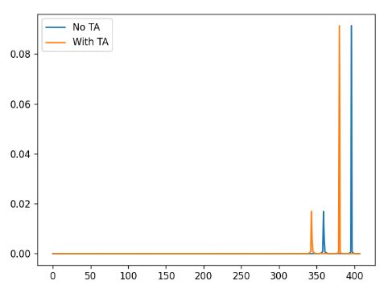.

**[Note]** In this competition, the channel provided is in the frequency domain, specifically SRS (Sounding Reference Signal) channels. The frequency and delay domains are Fourier transformed pairs. By performing a DFT on the delay domain channel, you can obtain the frequency domain channel; performing an IDFT on the frequency domain channel gives the delay domain channel.

#### **TA Range in Final Channel Data**

For channels used for on-site Hackathon, the TA range is between -8Ts and +8Ts, where Ts is defined as the time unit in 5G NR:

$$1Ts=\frac{1}{SCS*FFTSize}=\frac{1}{30*1000*2048}s≈16.28ns$$

Which means that the TA range is approximately from -130ns to 130ns. Each user's TA value is a random variable that is applicable to the whole band, meaning that each terminal’s channel TA value is identical across all subcarriers.